Greetings,

We look forward to satisfying your DITPR-DON RM Tab requests.

Please complete the information below and send to the “USMC HQMC AR ARD ARDB RECORDS” org box in TMT or via email to HQMC-MGR@usmc.mil:

To: USMC HQMC AR ARD ARDB RECORDS
Subject: “DITPR-DON RM Tab Request for System(s) _______”
DON SSIC: 5000- General Operations - Administration and Management
Suspense/Due Date: (Please give us at least 2 business days response time)

Please complete the following:

DITPR-DON ID
System Acronym
Name of System
POC (to contact with questions)
POC phone
POC email
Does this system contain ANY records?  Note: Even systems that collect information from other systems are likely to generate new records or retain copies of records. | Choose an item.
If the system contains records, is the Record Data scheduled with National Archives and Records Administration (NARA)? | Choose an item.
If Record Data is scheduled with NARA please provide the record schedule the Disposition Authority for the record schedule. (See page 2, figure 1).

Note: If Record Data is not scheduled with NARA or you are unsure, please visit https://hqmcportal.hqi.usmc.mil/org/ar/ard/ardb
On how to identify an appropriate Record Schedule applicable to the records stored in this system.
If having difficulty finding an applicable record schedule, please identify how long the records should be retained (i.e., Permanent or Temporary). | Choose an item.
If Temporary, please identify how long the records should live before they get destroyed.
Please provide a brief description of how this system processes records and what the records are used for.

*Note: Department of Navy and Marine Corps previously used what was known as Standard Subject Identification Codes (SSIC). The SSICs were replaced in Sept of 2019 with the new DON Bucket Record Schedules. Any previously identified SSICs now fall under a new DON BUCKET. Also, as a result, several dispositions (lifecycles) have changed, the dispositions that were previously associated with the old SSICs are obsolete – please make a note of this as the new required dispositions may impact your systems.

To locate an applicable record schedule:

Go to: https://login.secnav.navy.mil/
Complete your information and submit, portal will give you immediate access.
On the left side of the page, click on “DON/AA”
On the left side of the page, click on “DRMD”
In the middle of the page, click on the widget “Newly Approved Records Schedules”
Open the folder “Schedules Cross Walked by Chapter”
Here you will see all 13 chapters (excel files) of the new record schedules

Open up the chapter that is applicable to the content of the records.

Once you’ve opened up the chapter, you’ll see a spreadsheet that looks like this:

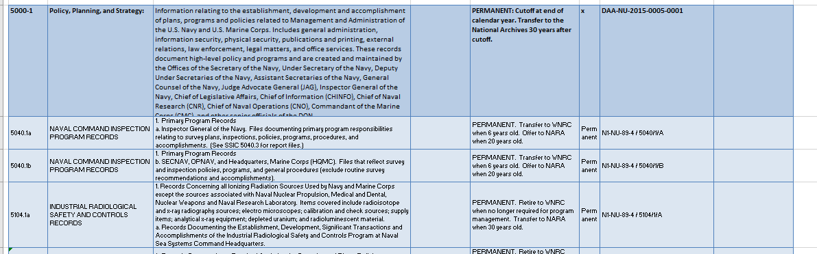

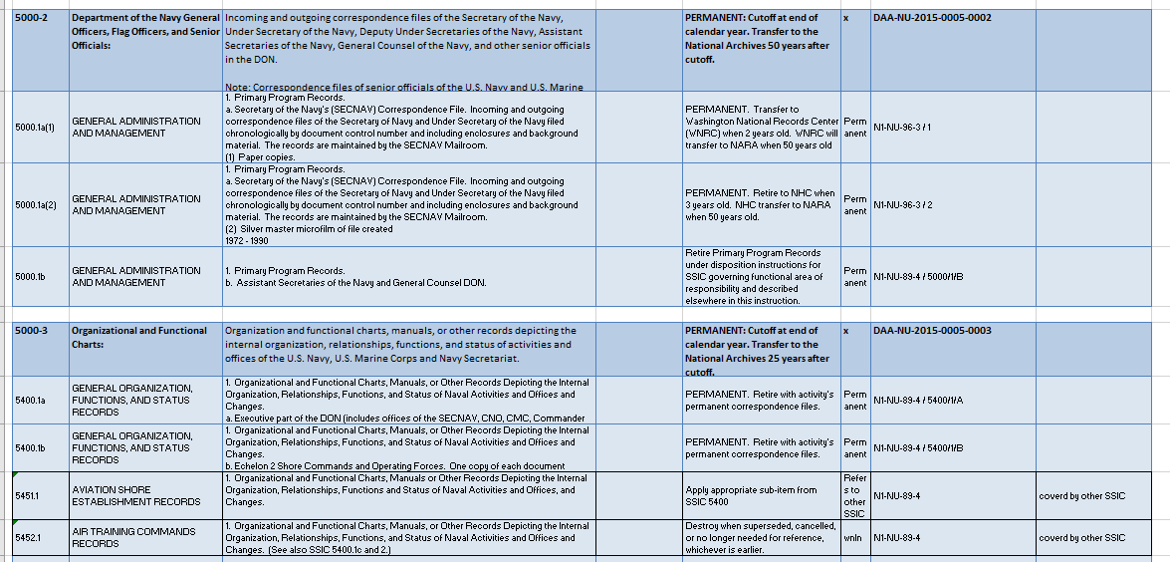

The new record schedule is the dark shaded row (i.e., 5000-1, 5000-2, 5000-3, etc.). This replaces the old SSIC number.

The new disposition for this record type is also listed in the dark shaded row.
Example: For record schedule 5000-3, the disposition is: PERMANENT: Cutoff at the end of calendar year. Transfer to the National Archives 25 years after cutoff.

The Disposition Authority is also in the dark shaded row.
Example: For record schedule 5000-3, the disposition authority is DAA-NU-2015-0005-0003

The light shaded rows that immediately follow a dark shaded row are all the old/obsolete SSIC numbers and dispositions. These dispositions no longer apply.
Example: If a system used to be identified using the SSIC 5452.1 and followed the disposition to “Destroy when superseded, cancelled, or no longer needed for reference, whichever is earlier,” the system will now need to use record schedule 5000-3 and the disposition, “Permanent: Cutoff at end of calendar year, Transfer to National Archives 25 years after cutoff.”

Please contact ARDB with any questions you may have: HQMCREC-MGR@usmc.mil

